QUICKR_PICKR (PROJECT 1)  
QA/UAT (USER ACCEPTANCE TESTING) DOCUMENT  
_______________________________________________________

**User Story: US001  
Feature/Capability (FE001):** Questionary A with Options YES/NO, where:

* Option "NO" returns the user back to homepage, and
* Option "YES" display Questionary B with Options YES/NO.

|  |  |  |  |
| --- | --- | --- | --- |
| **#** | **Test Case** | **Expected Result** | **Verdict** |
| **1** | Verify the python file "quickr_pickr" can run without error and populate the questionary A's welcome message with options (YES/NO) | On running python file: "quickr_pickr.py" it must perform the questionary A's functionality by displaying the welcome message with options (YES/NO) | **PASS** |
| **2** | Verify the questionary A's "NO" option sends the user one step back & display "Goodbye!!" | On choosing questionary A's option "NO" it must display the one step back to user with "Goodbye!!" message. | **PASS** |
| **3** | Verify the questionary A's "YES" option display the questionary B to download the momentum data with 2 criteria (Short Term/Long Term) | On choosing questionary A's option "YES" it must display questionary B's criteria with options (Short Term/Long Term) | **PASS** |

SCREENSHOT: SCENARIO 1

**Questionary A:** Questionary display the message: "Welcome! Are you ready to use Quickr Pickr?" with options: "YES/NO".

**Python File Performance:** "python quickr_pickr.py" without error.

SCREENSHOT: SCENARIO 2

**Message Outcome:** Option "NO" display the message: "Goodbye!!"

**Option "NO":** Choosing the option "NO" send the user back with "Goodbye!!" message.

**Option "YES":** Choosing the option "YES" display a new questionary with 2 options (Short Term/Long Term Indicators).

**Questionary B:** Questionary B display the message: "Would you like to see short or long term indicators? " with options (Short Term Indicators/Long Term Indicators)

SCREENSHOT: SCENARIO 3

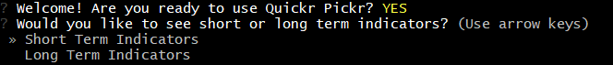

**User Story: US002  
Feature/Capability (FE002):** Questionary B with Options Short Term/Long Term Indicators, where:

* Option "Long Term" display the Momentum Data for long term period, and
* Option "Short Term" display the Momentum Data for short term period.

And, both options leads to Questionary C as a confirmation message with options YES/NO.

|  |  |  |  |
| --- | --- | --- | --- |
| **#** | **Test Case** | **Expected Result** | **Verdict** |
| **4** | Verify the questionary B's option "Long/Short Term" display questionary C's confirmation message with options (YES/NO) | On choosing questionary B's option "Long/Short Term" it must display questionary C's confirmation message with options (YES/NO) | **PASS** |
| **5** | Verify the questionary C's option "NO" sends the user back & display message: "Goodbye!!" | On choosing questionary C's option "NO" it must display the one step back to user with "Goodbye!!" message. | **PASS** |
| **6** | Verify the questionary C's option "YES" display the momentum data for Short/Long term Indicators. | On choosing questionary C's option "YES" it must display the momentum data for Short/Long Term Indicators. | **PASS** |

SCREENSHOT: SCENARIO 4 & 5

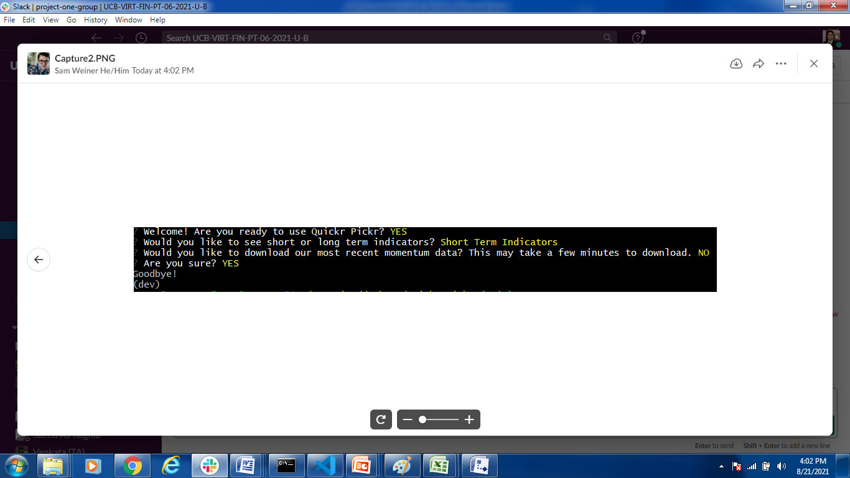

**Message Outcome:** Option "NO" display the message: "Goodbye!!"

**Option "NO":** Choosing the option "NO", it display the confirmation message: "Are you sure?" & choosing the confirmation as "YES", it send the user back to homepage with "Goodbye!!" message.

SCREENSHOT: SCENARIO 6

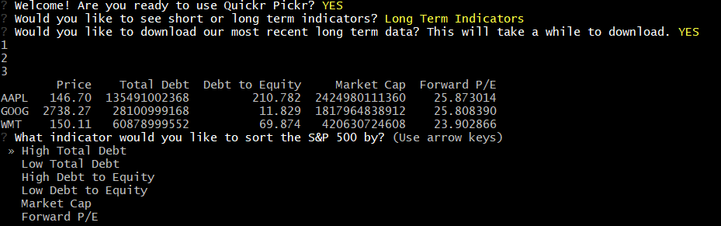

**Momentum Data:** Display the Momentum Data for Tickers with: "Price", "RSI", "MACD_Strength", "SMA50%", "Debt to Equity", "Total Debt" & "Market Cap".

**Option "YES":** Choosing the option "YES", it display the Momentum Data depending on the Indicator preference: Short Term OR Long Term.

**User Story: US003  
Feature/Capability (FE003):** Questionary D offers multiple Options of Indicators to choose from, where:

* Each Indicator (option) display Questionary E with multiple Options to choose from, and
* Questionary E for chosen "Indicator" display 3 options: "Chart", "Info" & "Neither"

|  |  |  |  |
| --- | --- | --- | --- |
| **#** | **Test Case** | **Expected Result** | **Verdict** |
| **7** | Verify the questionary D's display all Indicators (Product) as options to select. | On choosing questionary C's option YES, questionary D must display all Indicators (Product) as options to select | **PASS** |
| **8** | Verify the questionary D's options to select desired indicators display the Momentum Data. | On choosing questionary D's option (Indicator), it must display the Momentum Data. | **PASS** |
| **9** | Verify the questionary E's option (Indicators) display 3 options: Chart, Info & Neither. | On choosing questionary E's option (Indicators), it must display the 3 options: Chart, Info & Neither. | **PASS** |

SCREENSHOT: SCENARIO 7



**Questionary D's Indicators:** Display all the Indicators (Product) to select to get more detailed data.

**Questionary C's Option "YES":** Choosing Option YES display the Questionary D with Indicators as options.

SCREENSHOT: SCENARIO 7 & 8

**Questionary E's Options:** Display the Options to choose from: "Chart", "Info" & "Neither".

**Questionary D's Options:** Display the Momentum Data of selected Option (Indicators).

**User Story: US004  
Feature/Capability (FE004):** Questionary E with Options "Chart", "Info" & "Neither", where:

* Input Parameter Value is required as: "Ticker"
* Option "Chart": Display the visual (chart) for input parameter value "ticker"
* Option "Info": Display the detailed information for input parameter value "ticker"
* Option "Neither": Display the exit confirmation and returns the user back to homepage.

|  |  |  |  |
| --- | --- | --- | --- |
| **#** | **Test Case** | **Expected Result** | **Verdict** |
| **10** | Verify the questionary E's option "Chart" confirm input parameter "Ticker" value and display the Chart. | On choosing questionary E's option "Chart" and passing the input parameter value "Ticker", it must display the Chart for desired ticker. | **PASS** |
| **11** | Verify the questionary E's option "Info" confirm input parameter "Ticker" value and display the Chart. | On choosing questionary E's option "Chart" and passing the input parameter value "Ticker", it must display the Chart for desired ticker. | **PASS** |
| **12** | Verify the questionary E's option "Neither" confirms the user to exit the application and on "exit confirmation" send the user back to homepage. | On choosing questionary E's option "Neither" and it must ask the "exit" confirmation & display the "Thank you" message. | **PASS** |

SCREENSHOT: SCENARIO 10

**Input Parameter:** Display the "Input" message to pass the Input Parameter Value for desired "Ticker" (AAPL).

**"Chart" Option:** Display the "Additional Information" message to select "Chart" as selected option.

SCREENSHOT: SCENARIO 10

OUTPUT: CHART "AAPL Price & MACD for Last 6 Months"

**MACD Representation:** Display the "MACD" for last 6 months for ticker: "AAPL".

**Price Representation:** Display the "Price" for last 6 months for ticker: "AAPL".

SCREENSHOT: SCENARIO 11

OUTPUT: DETAILED INFO "Ticker: AAPL"

**Input Parameter:** Display the "Input" message to pass the Input Parameter Value for desired "Ticker" (WMT).

**"Info" Option:** Display the "Additional Information" message to select "Info" as selected option.

SCREENSHOT: SCENARIO 11

OUTPUT: DETAILED INFO "Ticker: AAPL"

SCREENSHOT: SCENARIO 11

OUTPUT: DETAILED INFO "Ticker: AAPL"

SCREENSHOT: SCENARIO 11

OUTPUT: DETAILED INFO "Ticker: AAPL"

SCREENSHOT: SCENARIO 11

OUTPUT: DETAILED INFO "Ticker: AAPL"

SCREENSHOT: SCENARIO 11

OUTPUT: DETAILED INFO "Ticker: AAPL"

SCREENSHOT: SCENARIO 12

**Exit Confirmation:** Display the "Exit Confirmation" message with "Thank you" message on confirming YES.

**"Neither" Option:** Display the "Additional Information" message to select "Neither" as selected option.